**User Guide for Zebreafish Projector GUI**

1. Install:
   1. Download the Projecotor GUI from GitHub: <https://github.com/stardust-t/ZerbrafishProject>.
   2. Install Psychophysics toolbox 3 :

1.2.1 For Windows:

1. <http://psychtoolbox.org/download/#Windows> Follow the installation guide on the web page above.
2. (Alternatively) Install SVN by the installer in .\ZebrafishGUI\Install\Slik-Subversion-1.9.4-x64.msi

Reboot. (Important!)

Run installation script: .\ZebrafishGUI\Install\Setup.m

1.2.2 For Linux:

<http://neuro.debian.net/install_pkg.html?p=matlab-psychtoolbox-3> First install the NeuroDebian with **all software** option, than install psychtoolbox-3.

* 1. (Optional, for trigger IO) Trigger setting:

Matlab Data Acquisition Toolbox needed.

Using a NI USB-6501 for IO control, use the port 0 / line 1 as Trigger 1 (Movie Start Trigger), and port0 / line2 as Trigger 2 (spot on Trigger).

Port setting and Devices setting can be changed in the GUI open function: *ProjectionGUI_OpeningFcn.*

NI Drivers for the IO devices (NI-DAQmx)need to be installed:

<http://www.ni.com/download/ni-daqmx-15.5/5901/en/>

* 1. A second Monitor should be connected, and set the monitor to the “expansion mode”, movie will be projected on the 2nd monitor.
  2. Run the ProjectionGUI.m, the following interface should be displayed:

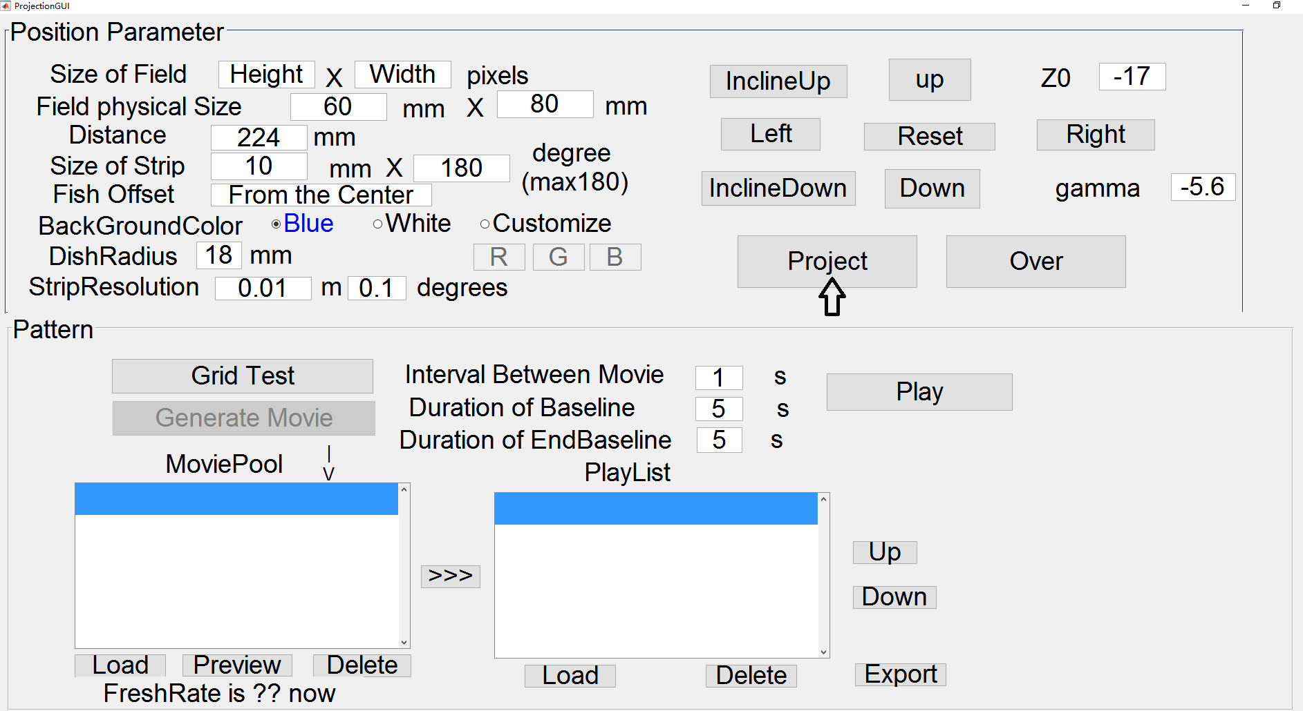

Click on the **Project** button to test whether installation succeeded. If succeeded, a black cylindrical orthogonal projection in the blue background should display on the second monitor.

1. Set the proper projection parameter.
   1. The upper plane (Position Parameter) is used to set the projecting parameter.

Schema as below.

**Size of Field**: The resolution of the projector. Parameters will be automatically obtained from the projector if it is not set manually.

**Field physical Size**: The physical height and width of the projecting image when projecting in the setting Distance. Need to be measured to give accurate project of image.

**Distance**: distance between the center of the projector lens to the center (at both height and circle). Unit in millimeter. *For projecting into a plain board. Just simply set the **Distance** to a big value and set the **DishRadius** to (Distance – realDistance). For example, if the real distance from the projector to the plain board center is 150mm, set the **Distance** to 10000, and set the **DishRadius** 9850 (which is 10000 - 150). In this way, the GUI can be used to project to the plain board.

**Size of Strip:** The strip width and height you want to projected. The height usually is the dishes height if one demands the image filling the whole height of the dishes. And the width is unit in degrees, the degrees count from the left side of the dishes (Follow the projecting direction). So the center of the strip would be 90 degrees, and it is the center of the dish.

**Fish Offset**: Unfunctioned parameter, left for further use for correcting if the fish is not in the center of the dish.

**InclineUp/InclineDown:** Incline up will increase the gamma and incline down will decrease the gamma. For manually adjust the incline angle (not recommend) when the real angle can’t be obtained.

**Gamma:** Used for set the incline angle of the projecting direction (recommend). Unit in degrees.

**Up/Down:** Up will decrease the Z0 (which means the objector is going down), and Down will increase the Z0 (Projector is going up).

**Z0:** The displacement of projector in Z axis (perpendicular) from the upper border of the dish (showed in Schema). When the projector is higher than the dish, this value is negative. Unit in millimeter.

**Project:** Start the project or refresh the image with current projecting parameters.

**Over:** Turn off the image projecting.

**figure1_DeleteFcn/ProjectionGUI_OpeningFcn:** Close function and opening function of the GUI. IO trigger channels connected and disconnected function also included in these two function (If applied, see 1.3).

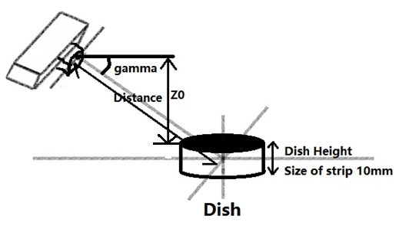

1. Making the Movie (PlainPainter.m).
   1. After set the project parameters and click **Project** button, if projecting successfully, the **Generate Movie** button would be enable, allow user to generate movie.
   2. Click on **Generate Movie** button, a file chose guide will pop out, first one is for choosing the undistorted movie (Plain Movie) to applied a correct distortion for project into the cylinder. For paint a movie from the beginning using the PlainPainter, click **Cancel.** Second file choosing guide is used for select the save path of the Movie (If draw using the PalinPainter, the PlainMovie will also be saved in this directory with a prefix PlainMovie-).
   3. Generate movie using **PalinPainter.** When the user does not choose a plain movie to generate, the PlainPainter interface would be open, and the interface is look like below. There are two subpages tag – **Spot** and **Bar**.

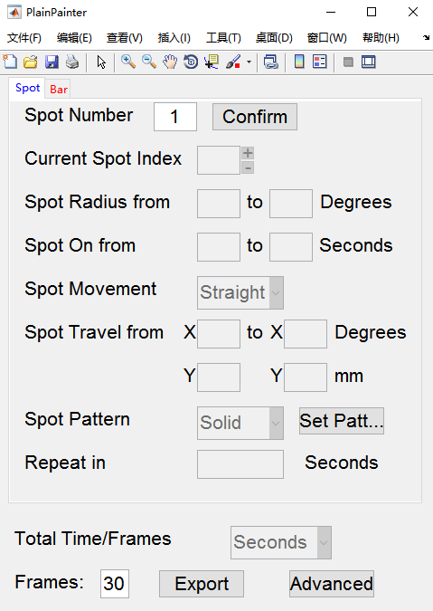

Spot subpage

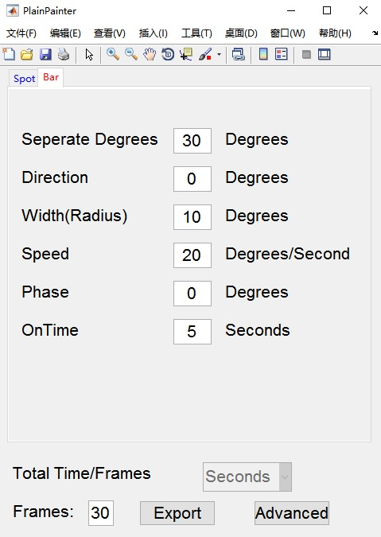

Bar subpage

* 1. Generate spot movie
     1. First tell the PlainPainter how many spots have to be generated in **Spot Number**, and click **Confirm** button. Change the **Current Spot Index** to specify properties for every spot. If you want a same spot stimulation repeat in several times, input a vector in **Repeat in** textbox. For example, if you want a simply spot show 0s-1s, 5s-6s, 10s-11s, input **5,10,15** or **5 10 15** in the **Repeat in** textbox will do the trick.
     2. Change the refresh rate to accelerate the movie generation.

In the **Frames** textbox, one can specified how many frames per second should the movie be generated. In a lower frames fresh rate, the movie would be generating quickly than a high frames refresh rate. But for accurate stimulation, one should always assign the frames fresh rate a divisor of the fresh rate of the projector (Which can be found on the bottom of the Main GUI) to avoid refresh rate inaccuracy, for example, if the refresh rate of the projector is 60Hz, the refresh rate using for generate movie should be chosen from, 1,2,3,4,5,6,10,12,15,20,30,60.

* + 1. Generating spot in user defined trajectory

In **Spot Movement** pop menu, choose **Trail**. And back to the matlab command line, you will be asked to input the X(t) and Y(t), X(t) is the function which gives the X position of the spot center in time, X is unit in degrees, and count from the most left side of the strip. For example, if one want to generate a spot at the middle of the strip, but oscillate in vertical direction, the position function should be input as below: X(t) = 90, Y(t) = 5 + sin(t). !Do not let the spot go out of the boundary (have to count the spot size), it will cause error and failed to generate the movie!

* 1. Generate drafting bar for orientation test

Choose the Bar subpage, and specify the parameters of the drafting bar. The **Frames** can also be used to change the refresh rate, the same as it in the spot movie generation.

1. Store the Movie.

Both plain movie and the projecting movie would be saved under the directory chose by the user (see 3.1), and the movie information will also be saved in the mat file (field *PlainMovieInfo*, and *MovieInfo*).

1. Load the Movie.

To load a projecting movie, click **Load** button below the **MoviePool** listbox, and the movie can be previewed by using the **Preview** button. Click **>>>** button, can insert the movie into **PlayList**, same movie can be insert into **PlayList** for seveal times for repeatedly play.

1. Play the Movie with Trigger.

Click **Play** button the movie would be played with the order in the **PlayList**. Set the start waiting time in **Duration of BaseLine** and the end waiting time in **Duration of EndBaseline,** and set the interval between movie in the **Interval Between Movie.**

If the IO trigger device is being set up, a start trigger would be sent through the first channel when the movie begins, and a spot on trigger would be sent through the second channel when there is a spot pop out in the movie (only at the time point when the spot firstly showed). For detail, see the ***ProjectionGUI_OpeningFcn, Play_Callback*** and ***Trigger*** function.